**一种基于分子内环化反应的荧光触发型探针用于硫化氢的检测**

邢宏杰，吴选俊，吴浩，杨柳*，韩守法*

（厦门大学化学化工学院，福建厦门 361005）

**摘要：**硫化氢（H2S）是一种重要的气体信号分子，参与调节多种生物过程。对生物样品内的硫化氢进行选择性成像是理解其生理功能的一个重要手段。本文报道一种具有新型反应机理的无荧光探针（DNP-CMP）硫化氢检测中的应用。通过硫化氢介导硫解反应可脱除DNP-CMP的二硝基苯醚保护基，而暴露的羟基引发探针的分子内环化反应，生成荧光分子香豆素，从而实现硫化氢的低背景检测。DNP-CMP检测硫化氢的专一性高，可藉以实现细胞内硫化氢的荧光成像。

**关键词：**硫化氢；荧光成像；二硝基苯醚；触发型荧光探针

**中图分类号：O657.3文献标志码：A**

研究表明，硫化氢是一种内源性气体信号传导分子，调节多种生物功能，包括细胞信号传导、血管舒张和炎症等[1-3]。内源性硫化氢可以在多种组织中产生，如脑、肝脏、结肠等[4]。在许多病理条件下，如炎症中，内源性硫化氢的浓度水平升高[5]。**因此，发展一种灵敏、高选择性、低背景的测量生物样本中硫化氢的方法对于对理解硫化氢的生物学功能具有重要意义。**

荧光分子探针具有非侵入性，便于操作，可提供目标检测物的分布与含量等实时信息，是检测生物样本的理想工具。近两年，有较多关于检测硫化氢荧光探针的报道。这些探针多利用硫化氢的还原性或亲核性来引发信号的产生：比如硫化氢诱导叠氮基还原为氨基[6-25]，铜离子离去后荧光恢复[26-29]，2,4-二硝基苯醚硫解[30-35]，二硫键断裂[36-38]及亲核性[39-46]等。

林伟英等于2012年报道了一种基于硫化氢对二硝基苯醚的硫解反应[31]检测硫化氢的荧光探针（图1(A)）。基于上述研究，我们设计、合成了一种新型小分子探针（DNP-CMP）用于检测硫化氢（图1(B)）：硫化氢与DNP-CMP的二硝基苯醚位发生硫解反应，脱除二硝基苯醚保护基，暴露的羟基进一步引发分子内环化反应，得到具有荧光的香豆素。



图1基于DNP保护基的硫化氢荧光探针

Fig. 1H2S-resposnive chemodosimters featuring a dinitrophenyl ether moiety

________________________________

**收稿日期：2014-02-28**

**基金项目：**国家自然科学基金（21305116，21272196）; 湖南大学化学生物传感与计量学国家重点实验室基金开放课题（2012002）

**\*通信作者：**[shoufa@xmu.edu.cn](mailto:shoufa@xmu.edu.cn)；[yangliu@xmu.edu.cn](mailto:yangliu@xmu.edu.cn)

**1 实验部分**

* 1. **试剂**

无水硫氢化钠和丙二酸二乙酯（Alfa Aesa 试剂公司），4-二乙基氨基水杨醛和2,4-二硝基氟苯（西亚试剂），哌啶、醋酸、无水碳酸钾、乙腈、二甲亚砜、乙酸乙酯、二氯甲烷、石油醚（国药集团化学试剂有限公司）。所有试剂均为分析纯（乙腈为HPLC纯），未经特殊说明均未经过特别处理。柱层析硅胶（300~400目）购于黄海化学试剂公司。测试所用水均为超纯水（18.2 MΩ·cm）。

* 1. **仪器**

酶标仪（荧光分析）：Spectra Max M5；低分辨质谱仪：Bruker Dalton Esquire 3000 plus；核磁共振仪：Bruker AV 400MHz；激光共聚焦显微镜：Leica SP5。

* 1. **探针的合成与表征**



图2探针DNP-CMP的合成

Fig. 2Synthesis of DNP-CMP

称取2.0 g 4-二乙基氨基水杨醛置于50 mL圆底烧瓶中，然后向反应瓶中加入30 mL N,N-二甲基甲酰胺与2.2 g 2,4-二硝基氟苯和少量无水碳酸钾。反应体系在室温下搅拌12 h后，反应液过滤，将滤液用二氯甲烷-水（30 / 30 mL）萃取两次。有机相合并，用无水硫酸钠干燥，减压蒸掉溶剂，所得粗产品经过柱层析分离（V(石油醚):V(二氯甲烷) = 2 : 1）得到中间体A（3.42 g，产率：92 %）。1H-NMR (400 MHz, CDCl3): δ9.76 (s, 1H), 8.86 (t, 1H, J = 2.76 Hz), 8.30 (dd, 1H,J1 = 9.26 Hz , J2 = 2.74 Hz), 7.77 (d, 1H, J = 8.96 Hz), 7.03 (d, 1H, J = 9.24 Hz), 6.66 (dd, 1H, J1 = 8.96 Hz , J2 = 2.36 Hz), 6.31 (d, 1H, J = 2.44 Hz), 3.45 (q, 4H, J = 7.12), 1.23 (t, 6H, J = 7.12 Hz); 13C-NMR(100 MHz, CDCl3): 185.46, 156.47, 156.36, 153.70, 141.27, 138.83, 133.54, 128.82, 122.70, 117.61, 115.47, 109.32, 102.73, 44.91, 12.32。

向50 mL圆底烧瓶依次加入2.0 g 化合物A，30 mL无水乙醇，1.0 mL丙二酸二乙酯，催化量的哌啶和一滴醋酸。反应体系搅拌、加热回流4 h后，反应液用二氯甲烷-水（30 / 30 mL）萃取两次。合并后的有机相经无水硫酸钠干燥后，减压除去溶剂。所得粗产品经柱层析分离（V(石油醚)：V(二氯甲烷)=15 : 1）得到橙黄色固体粉末为DNP-CMP（2.78 g，产率：90 %）。1H-NMR (400 MHz, CDCl3): δ8.33 (d, 1H, J = 2.64 Hz), 8.30 (dd, 1H, J1 = 9.26Hz , J2 = 2.64 Hz), 7.69 (s, 1H), 7.45 (d, 1H, J = 9.04 Hz), 6.99 (d, 1H, J = 9.26Hz), 6.57 (dd, 1H, J1 = 9.08 Hz , J2 = 2.48 Hz), 6.28 (d, 1H, J = 2.48 Hz), 4.34 (q, 2H, J = 7.12 Hz), 4.18 (q, 2H, J = 7.12 Hz), 3.38 (q, 4H, J = 7.04 Hz), 1.33 (t, 3H, J = 7.12 Hz) , 1.24 (t, 3H, J = 7.12 Hz) , 1.18 (t, 6H, J = 7.04 Hz); 13C-NMR(100 MHz, CDCl3): 167.24, 164.36, 156.22, 154.21, 151.31, 141.34, 138.92, 134.82, 130.98, 128.94, 122.02, 118.16, 107.98, 102.79, 61.48, 61.25, 44.68, 14.04, 12.44。

* 1. **实验方法**

荧光光谱分析：荧光光谱实验在Spectra Max M5酶标仪上测试，配有1 cm的石英比色皿。激发波长：415 nm；发射波长：460 nm。

细胞培养：HeLa细胞（购自ATCC公司）用高糖Dulbecco’s Modified Eagle Medium（DMEM）培养液进行培养，培养液中加入10%的牛胎血清（FBS）和1%的抗生素（青霉素/链霉素100 U/mL）。空白组为细胞用不含硫氢化钠的培养基培养10 min；对照组为细胞用含有硫氢化钠的磷酸缓冲溶液（PBS）培养。

激光共聚焦成像：荧光共聚焦成像用Leica SP5型共聚焦激光扫描显微镜来完成。100倍物镜，405 nm 激发，然后收集420~500 nm 范围内的发射光强度。实验前将培养液倾出，然后用PBS缓冲液将细胞洗3次后进行细胞成像实验。

**2 结果与讨论**

**2.1 反应介质的优化**

为了探索反应介质对DNP-CMP检测硫化氢效率的影响，固定探针DNP-CMP浓度为20 μmol/L，硫氢化钠浓度为100 μmol/L；测量二者在CH3CN, EtOH, PBS-CH3CN (体积比4:1)介质中反应30 min后的荧光光谱。实验结果如图3所示，探针在CH3CN与EtOH中均可有效检测硫化氢，而在CH3CN中表现出最高荧光强度。因此，CH3CN是探针DNP-CMP与硫化氢反应的较好介质。

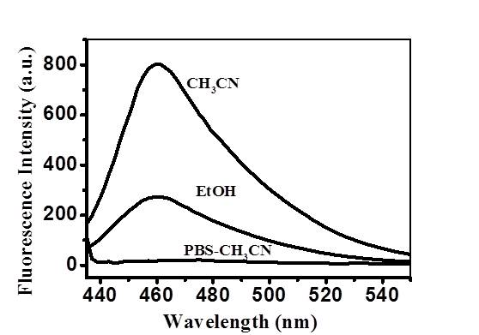

图3反应介质对DNP-CMP检测硫化氢的影响

Fig. 3Effects of the reaction media on sensing of H2Swith DNP-CMP

* 1. **反应机理的探索**



图4DNP- CMP与H2S的反应机理

Fig. 4Proposed reaction mechanism of DNP-CMPwith H2S

我们设想硫化氢与探针DNP-CMP的二硝基苯醚发生硫解反应，继而通过串联发生亲核加成关环消除反应，最终得到具有荧光的香豆素产物（图4）。为验证设想的机理，实验中向含有DNP-CMP的乙腈溶液中加入硫氢化钠。观察到反应液颜色立刻由无色透明变成黄褐色。通过对反应液的质谱表征，发现了产物香豆素的峰（C16H19NO4 +Na+：312.0；理论相对分子质量C16H19NO4：289.1）。所得结果初步证实了图4所描述的DNP-CMP与硫化氢的反应机理。

* 1. **动力学曲线**

为了优化DNP-CMP检测硫化氢的反应时间，测试了不同反应时间DNP-CMP与硫氢化钠反应液（乙腈）的紫外-可见吸收与荧光发射。如图5所示：所得数据显示DNP-CMP与硫化氢反应15~20 min，即可产生较明显的紫外-可见吸收和荧光信号。

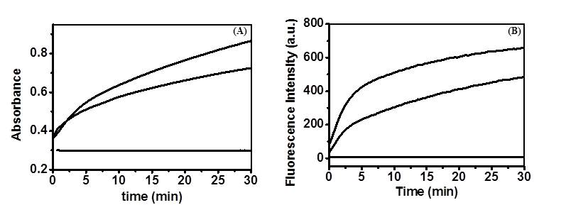

DNP-CMP (20 μmol/L)与不同浓度硫氢化钠(0, 50, 100 μmol/L, 从下到上)（A）为反应液在410 nm 处的紫外-可见吸收的时间关系曲线；（B）为反应液在460 nm处的荧光发射强度的时间关系曲线（激发@415 nm）。

图5DNP-CMP与硫化氢化学反应的动力学曲线

Fig. 5 Kinetic profiles of sensing of H2S with DNP-CMP

* 1. **探针**DNP-CMP**的检测限**

为了考察DNP-CMP检测硫化氢的检测限，将含有DNP-CMP与不同浓度硫化氢的乙腈溶液于室温下孵育20 min，然后测量反应液的紫外-可见吸收和荧光发射强度。实验结果如图6所示：图6 (A)和(B)数据显示随着硫化氢浓度的增高，反应体系在415 nm处的紫外-可见吸收呈线性增加；图6 (C)和(D)数据表明随着硫化氢浓度的增高，其在460 nm处的荧光发射强度也相应增强；而且当硫化氢浓度在为5 μmol/L时，DNP-CMP仍有较好的荧光响应。所得的荧光分析数据与紫外-可见吸收分析数据相吻合，说明DNP-CMP能够有效检测5~200 μM的硫化氢。经过计算DNP-CMP的IUPAC定义检测限为0.07μmol/L。

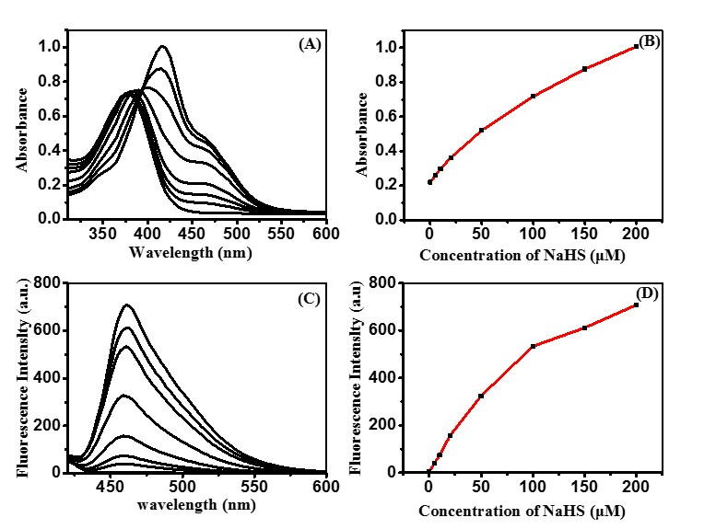

DNP-CMP (20 μmol/L)在乙腈中与不同浓度硫氢化钠(0, 5, 10, 20, 50, 100, 150, 200 μmol/L, 从下到上)孵育20 min：(A)为反应的紫外-可见吸收光谱；(B)为反应液415 nm吸收值的滴定曲线；(C)为反应的荧光发射光谱（激发波长@415 nm）；(D) 为反应液460 nm处的荧光滴定曲线(激发波长@415 nm)

图6探针与不同浓度的硫化氢反应的紫外-可见吸收光谱和荧光光谱及其相应的滴定曲线

Fig. 6Quantitation of NaHS with DNP-CMP by UV-vis spectrometry (A) and fluorometry (C).The titration curve was plotted by absorbance at 415 nm (B) or fluorescence emission at 460 nm (D) vs NaHSconcentration.

* 1. **探针**DNP-CMP**的选择性**

硫化氢含有巯基，而生物体内存在多种含有巯基的生物分子：如谷胱甘肽（glutathione），半胱氨酸（cysteine），同型半胱氨酸（homocysteine）等。为了辨别它们是否干扰DNP-CMP对硫化氢的识别，我们首先检测了DNP-CMP(20 μmol/L)对硫化氢和多种含有巯基的生物分子在乙腈介质中的荧光响应。结果如图7（A）所示，硫化氢能够引发探针产生强烈的荧光，而所测试多种含巯基化合物均不引发DNP-CMP产生荧光。生物体系中存在多种多样的金属离子（如Fe3+、Ca2+、Na+、K+等）和阴离子（如Cl-、I-等）。因此，我们检测并验证DNP-CMP对常见的多种活性金属离子和阴离子均不产生荧光响应（如图7）。实验结果证实了DNP-CMP识别硫化氢的专一性。

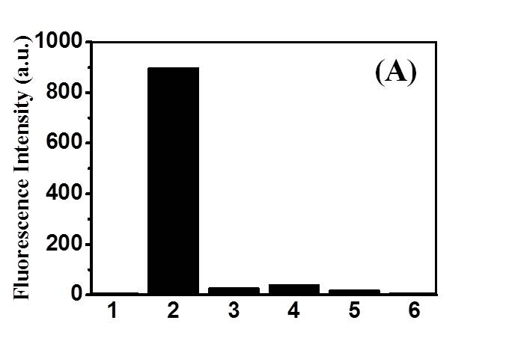

（1为空白；2为0.1 mmol/L硫氢化钠；3为1 mmol/L半胱氨酸；4为1 mmol/L同型半胱氨酸；5为1mmol/L谷胱甘肽；6为1 mmol/L β-巯基乙醇）

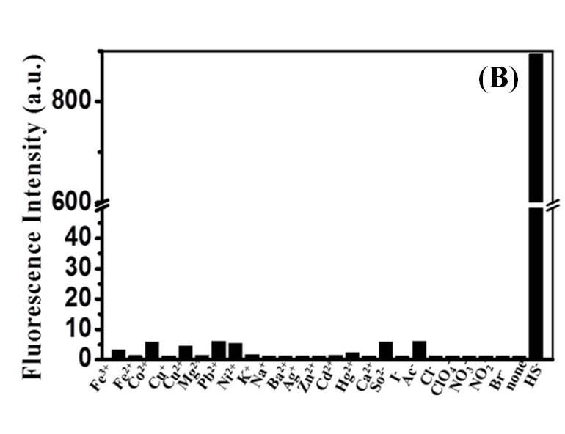

图7探针DNP-CMP对硫化氢选择性

Fig. 7Selectivity of DNP-CMP for H2S.

* 1. **细胞内硫化氢成像**

在确定了DNP-CMP识别硫化氢的高专一性后，我们探索其在细胞内识别硫化氢产生荧光的可行性。将DMEM中培养24 h的HeLa细胞加入到含有100 μmol/LDNP-CMP的PBS孵育细胞20 min，之后向培养液中加入1 mmol/L硫氢化钠，并在续培养10 min（对照组的细胞培养液不加入硫氢化钠）。所得细胞用PBS洗后，在激光共聚焦显微镜下进行成像分析。结果表明培养液加入硫化氢进行孵育的细胞内有明显的荧光信号，主要分布在细胞质中；而在对照实验组的细胞内荧光很弱（图8）。实验中细胞的形态完好，说明DNP-CMP具有很好的细胞膜透性，有效进入细胞内部。所得结果显示DNP-CMP能够有效对细胞内硫化氢进行荧光成像。

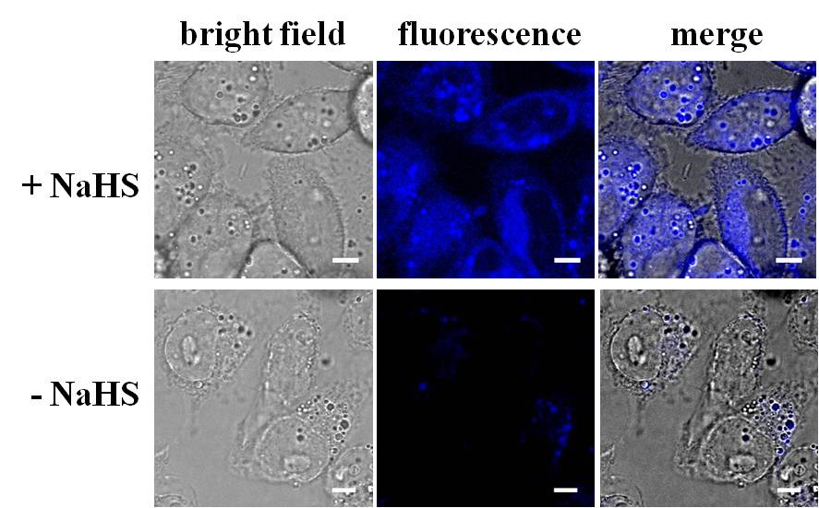

（激发光源405 nm，在420~500 nm通道观察细胞内荧光强度）

图8HeLa细胞在硫化氢孵育前后的共聚焦荧光成像图（标尺：10 μm）

Fig. 8Imaging of H2S in HeLa cells with DNP-CMP( Bar: 10 μm)

1. **结论**

我们设计、合成了一种具有新型反应机理的“荧光产生”型小分子探针DNP-CMP，用于硫化氢的识别。探针DNP-CMP为二硝基苯醚结构保护酚氧基的香豆素前体，硫化氢通过将无荧光探针的二硝基苯醚保护基硫解离去，触发分子内串联发生亲核加成关环消除，得到具有荧光的香豆素，从而实现对硫化氢的低背景荧光检测。DNP-CMP的合成原料易得，合成方法简单。DNP-CMP对硫化氢具有较高的灵敏度与高度选择性，可以用于生理条件下生物样品中硫化氢的荧光成像研究。

**参考文献：**

[1] Blackstone E, Morrison M, Roth MB. H2S induces a suspended animation-like state in mice[J]. Science, 2005,308(5721):518.

[2] Calvert J W, Coetzee W A, Lefer D J. Novel insights into hydrogen sulfide-mediated cytoprotection[J]. Antioxid Redox Signal, 2010,12(10):1203-1217.

[3] SzaboC. Hydrogen sulphide and therapeutic potential[J]. Nature Reviews Drug Discovery, 2007,6:917-935.

[4] Linden D R, Sha L, Mazzone A, et al. Production of the gaseous signal molecule hydrogen sulfide in mouse tissues[J]. Journal of Neurochemistry, 2008, 106(4):1577-1585.

[5] Wallace J L, Vong L, McKnight W,et al.Endogenous and exogenous hydrogen sulfide promotes resolution of colotos in rats[J]. Gastroenterology, 2009, 137(2):569-578.

[6] Yu C M, Li X Z, Zeng F, et al.Carbon-dot-based ratiometric fluorescent sensor for detecting hydrogen sulfide in aqueous media and inside live cells[J]. Chemical Commuications, 2013,49(4):403-405.

[7] Wan Q Q, Song Y C, Li Z, et al. In vivo monitoring of hydrogen sulfide using a cresyl violet-based ratiometric fluorescence probe[J]. Chemical Commuications, 2013,49(5):502-504.

[8] Thorson M K, Majtan T, Kraus J P, et al. Identification of cystathionine β-synthase inhibitors using a hydrogen sulfide selective probe[J]. Angewandte Chemie International Edition, 2013,52(17):4641-4644.

[9] Sun W, Fan J L, Hu C, et al. A two-photon fluorescent probe with near-infrared emission for hydrogen sulfide imaging in biosystems[J]. Chemical Commuications, 2013,49(37):3890-3892.

[10] Sun K, Liu X L, Wang Y Y, et al. A polymer-based turn-on fluorescent sensor for specific detection of hydrogen sulphide[J]. The Royal Society of Chemistry Advances, 2013,3(34):14543-14548.

[11] Lin V S, Lippert A R, Chang C J. Cell-trappable fluorescent probes for endogenous hydrogen sulfide signaling and imaging H2O2-dependent H2S production[J]. PANS, 2013,110(18):7131-7135.

[12] Li W H, Sun W, YuX Q, et al.Coumarin-based fluorescent probes for H2S detection[J]. Journal of Fluorescence, 2013,23(1):181–186.

[13] Chen B F, Li W, Lv C, et al. Fluorescent probe for highly selective and sensitive detection of hydrogen sulfi de in living cells and cardiac tissues[J]. Analyst, 2013,138:936-951

[14] Yu F B, Li P, Song P, et al. An ICT-based strategy to a colorimetric and ratiometric fluorescence probe for hydrogen sulfide in living cells[J]. Chemical communications, 2012,48(23):2852-2854.

[15] Das S K, Lim C S, Yang S Y, et al. A small molecule two-photon probe for hydrogen sulfide in live tissues[J]. Chemical communications, 2012,48(67):8395-8397.

[16] Lippert A R, Mew E J, Chang C J. Reaction-based fluorescent probes for selective imaging of hydrogen sulfide in living cells[J]. Journal of the American Chemical Society, 2011,133(26):10078-10080.

[17] Xuan W M, Sheng C Q, Cao Y T, et al. Fluorescent probes for the detection of hydrogen sulfide in biological systems [J]. Angewandte Chemie International Edition, 2012,51(10):2282-2284.

[18] Peng H J, Cheng Y F, Dai C F, et al. A Fluorescent probe for fast and quantitative detection of hydrogen sulfide in blood[J].Angewandte Chemie International Edition, 2011,50(41):9672-9675.

[19] Wu Z S, Li Z, Yang L, et al. Fluorogenic detection of hydrogen sulphide via reductive unmasking of o-azidomethylbenzoyl-coumarin conjugate[J]. Chemical communications, 2012,48(81):10120-10122.

[20] Zhou G D, Wang H L, Ma Y, et al. An NBD fluorophore-based colorimetric and fluorescent chemosensor for hydrogen sulfide and its application for bioimaging[J]. Tetahedron, 2013,69(2):867-870.

[21] Zhang H T, Wang P, Chen G C, et al. A highly sensitive fluorescent probe for imaging hydrogen sulphide in living cells[J]. Tetrahedron Letters, 2013,54(36):4826-4829.

[22] Wang K, Peng H J, Ni N T, et al. 2,6-Dansyl azide as a fluorescent probe for hydrogen sulfide[J]. Journal of Fluorescence,2014, 24: 1-5.

[23] Tian H Y, Qian J H, Bai H Y, et al. Micelle-induced multiple performance improvement of fluorescent probes for H2S detection[J]. Analytica Chimica Acta, 2013,768:136-142.

[24] Mao G J, Wei T T, Wang X X, et al. High-sensitivity naphthalene-based two-photon fluorescent probe suitable for direct bioimaging of H2S in living cells[J]. Analytical Chemistry, 2013, 85(16):7875-7881.

[25] Chen T, Zheng Y, Xu Z Z, et al. A red emission fluorescent probe for hydrogen sulfide and its application in living cells imaging[J]. Tetrahedron Letters, 2013,54(23):2980-2982.

[25] Qu X Y, Li C J, Chen H C, et al. A red fluorescent turn-on probe for hydrogen sulphide and its application in living cells[J]. Chemical communications, 2013,49(68):7510-7512.

[26] Gu C F, Liu C H, Zhu YC, et al. Development of a boron-dipyrromethene-Cu2+ ensemble based colorimetric probe toward hydrogen sulfide in aqueous media[J]. Tetradedron Letters, 2011,52(39):5000-5003

[27] Zhang D Q, Jin W S. Highly selective and sensitive colorimetric probe for hydrogen sulfide by a copper (II) complex of azo-dye based on chemosensing ensemble approach[J]. Spectrochimica Acta Part A: Molecular and Biomolecular Spectroscopy, 2012,90:35-39.

[28] Hou F P, Cheng J, Xi P X, et al. Recognition of copper and hydrogen sul fi de in vitro using afluorescein derivative indicator[J]. Dalton Transactions, 2012,1(19):5799-5804.

[29] Wang J L, Long L P, Xie D, et al. Highly selective fluorescence turn-on sensor for hydrogen sulphide and imaging in living cells[J]. Journal of Luminescence, 2013,139:40-46.

[30] Sayed S EI, Torre C D L, Santos-Figueroa L E, et al. A new fluorescent “turn-on” chemodosimeter for the detection of hydrogen sulfide in water and living cells[J]. Advances, 2013,3(48):25690-25693.

[31] Cao X W, Lin W Y, Zheng K B, et al. A near-infrared fluorescent turn-on probe for fluorescence imaging of hydrogen sulfide in living cells based on thiolysis of dinitrophenyl ether[J]. Chemical communications, 2012,48(85):10529-10531.

[32] Wang J L, Lin W Y, Li W L. Three-channel fluorescent sensing via organic white light-emitting dyes for detection of hydrogen sulfide in living cells[J]. Biomaterials, 2013,34(30):7429-7436.

[33] Liu Y, Feng G Q. A visible light excitable colorimetric and fluorescent ESIPT probe for rapid and selective detection of hydrogen sulphide[J]. Organic& Biomolecular Chemistry, 2014, 12(3): 438-445.

[34] Liu T Y, Zhang X F, Qiao Q L, et al. A two-photon fluorescent probe for imaging hydrogen sulphide in living cells[J]. Dyes and Pigments, 2013,99(3):537-542.

[35] Liu T Y, Xu Z C, Spring D R, et al. A lysosome-targetable fluorescent probe for imaging hydrogen sulfide in living cells[J]. Organic Letters, 2013,15(9):2310-2313.

[36] Liu C R, Pan J, Li S, et al. Capture and visualization of hydrogen sulfide by a fluorescent

probe[J]. Angewandte Chemie International Edition, 2011,123(44):10511-10513.

[37] Xu Z, Xu L, Zhou J, et al. A highly selective fluorescent probe for fast detection of hydrogen sulphide in aqueous solution and living cells[J]. Chemical communications, 2012,48(88):10871-10873.

[38] Huang Q, Yang X F, Li H. A ratiometric fluorescent probe for hydrogen sulfide based on an excited-state intramolecular proton transfer mechanism[J].Dyes and Pigments, 2013,99(3):871-877.

[39] Qian Y, Karpus J, Kabil O,et al. Selective fluorescent probes for live-cell monitoring of sulphide[J]. Nature Communication, 2011,2:495-501.

[40] Wang X, Sun J, Zhang W B, et al. A near-infrared ratiometric fluorescent probe for rapidand highly sensitive imaging of endogenous hydrogen sulfide in living cells[J]. Chemical Science, 2013,4(6):2551-2556.

[41] Liu J, Sun Y-Q, Zhang J Y, et al. A Ratiometric Fluorescent Probe for Biological Signaling Molecule H2S:Fast Response and High Selectivity[J]. Chemistry European Journal, 2013,19(15):4717-4722.

[42] Li X, Zhang S, Cao J,,et al. An ICT-based fluorescent switch-on probe forhydrogen sulfide in living cells[J]. Chemical communications, 2013,49(77):8656-8658.

[43]Chen Y C, Zhu C C, Yang Z H. A Ratiometric fluorescent probe for rapid detection of hydrogensulfide in mitochondria[J]. Angewandte Chemie International Edition, 2013,125(6):1732-1735.

[44] Qian Y, Zhang L, Ding S T, et al. A fluorescent probe for rapid detection of hydrogen sulfide in blood plasma and brain tissues in mice[J]. Chemical Science, 2012,3(10):2920-2923.

[45] Liu C R, Peng B, Li S, et al.Reaction based fluorescent probes forhydrogen sulfide[J]. Organic Letters, 2012,14(8):2184-2187.

[46] Qian Y, Yang B Y, Shen Y N, et al. A BODIPY–coumarin-based selective fluorescent probe for rapidly detectinghydrogen sulfide in blood plasma and living cells[J]. Sensors and Actuators B: Chemical, 2013,182:498-503.

**An intramolecularcyclization based fluorogenic chemodosimeter for bioimaging of hydrogen sulfide**

**XING Hong-jie, WU Xuan-jun, WU Hao, YANG Liu** \***, HAN Shou-fa** *

**Abstract:** Hydrogen sulfide (H2S) is a gasotransmitter involved in a broad variety of biological processes including cell signaling, vasodilation and inflammation. H2S could be endogenously produced in various tissues such as brain and colon, and the levels of endogenousH2S are elevated under a number of pathological conditions. As such, methods enabling sensitive detection of H2S in biological samples are highly desirable. Herein we report a reaction-based assay of H2S with a dinitrophenyl group-masked coumarin precursor (DNP-CMP). Nonfluorescent DNP-CMP readily reacts with H2S via tandem nucleophilic removal of DNP moiety and intramolecular cyclization to give highly fluorescent coumarin. The dose-dependent “turn-on” fluorescence and the high selectivity of DNP-CMP towards H2S over other biological thiols enable low background bioimaging of H2S in living cells.

**Key words：**hydrogen sulfide; cell imaging; dinitrophenyl ether; fluorogenic chemodosimeter